JIM GOLD - 50 YEARS PRESENTATION

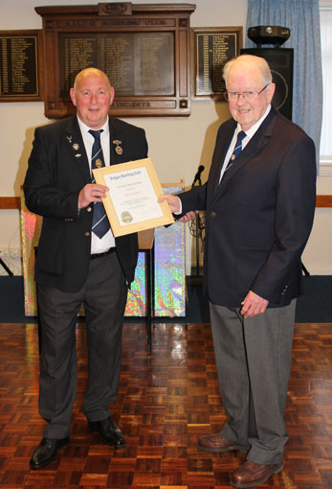

In April 1970 Jim Gold joined Balgay Bowling Club.
On the evening of 9th May 2019 a scroll was presented to Jim by
President G Sorrie to celebrate his fifty years with the club.

